FDOT-D6 TMC Internship Report
2013
Maria Guevara
Florida International University
7/26/2013

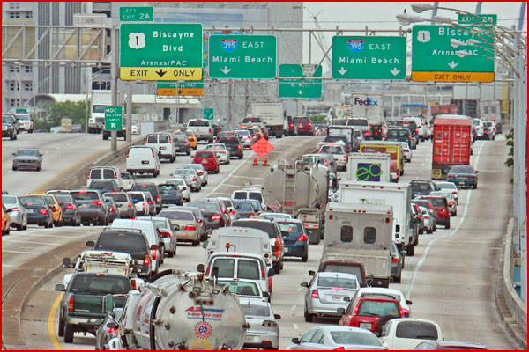

My name is Maria Guevara. I obtained my Bachelor’s of Science in Civil Engineering from Florida International University (FIU) in May 2012. I decided to continue with the graduate school to expand my knowledge and get exposed to real engineering problems. In August 2012, I had been accepted to Transportation Engineering Master’s Program and so far I had completed four of the ten required courses: Intelligent Transportation Systems, Advanced Highway Capacity, Advanced Geometric Design, and Traffic Signal Control. As a part of the Master’s Program I had the opportunity to participate in guest speaker sessions organized by the ITE Student Chapter. These sessions helped me to understand how broad the field of Transportation Engineering is and become more enthusiastic about my career. In April 2012, I became student assistant for the Lehman Center of Transportation Engineering and I had the opportunity to participate in different projects including Travel Time Study and Ramp Metering Measure of Effectiveness (MOE) Study. I also worked with Visual Roadway Inspection software to identify potential crash locations, and performed police reports analysis.
This summer, I was given the opportunity to be a part of the FIU Internship Program. I did my internship at Florida Department of Transportation (FDOT) District Six SunGuide Transportation Management Center (TMC). As part of the internship, I was involved in many activities and participated in some projects under the supervision of Mr. Alejandro Motta, Special Projects Coordinator. This experience changed my perspective of traffic engineering from the point of view of a regular user to the point of view of a proffessional who aims at learning more in the field of Traffic System Management and Operations and Intelligent Transportation Systems.
During my internship at TMC, I worked an average of twenty hours a week. As a part of the internship I collected data for the Ramp Metering MOE Study, participated in the Anti-texting Study, helped with the I-95/SR-9A Historical Crash Data Evaluation Report, analized Sunguide Raw Data and Sunguide Road Rangers Assist to validate the accuracy of the Operation Task Manager Software, tested Incident Detection Software, QA/QC D6 Comments on 511 users' traffic reports, and prepared Travel Time Reliability Monthly Report for July 2013.
Early this May, I took part of the Ramp Metering MOE Study. I worked in the field collecting metered ramps approximate queue lengths and individual vehicle waiting time meassured from the end of the queue to the ramp signal. This study is conducted once a year, Tuesday to Thursday, from 6:00 am to 10:00 am, and from 3:00 pm to 7:00 pm. The study includes 22 metered ramps between NW 62nd Street and Ives Dairy Road (NE 203rd Street). The objective of this study is to evaluate I-95 ramp signal operations during peak hours. At the end of the study I prepared collected data for processing. I also performed data collection field study to validate travel times generated by the SunGuide System and assisted with detectors data extraction from the Operator Task Manager (OTM) software as well.
I also was able to participate in a new study FDOT was conducting about the driver’s phone habits as they enter the expressway.We callected data three days each month (Tuesday, Wednesday, and Thursday), during peak hours (from 6:15 am to 9:30 am and from 3:15 pm to 6:30 pm) in 15 minutes intervals. The observers were asked to count drivers who were texting, talking or holding their phones when they approached I-95.
During my time at TMC, I conducted Incident Detection Software testing. Incident detection software uses data obtained from detectors and gives warning every time the speed on a freeway goes bellow certain threshold. This software could be very helpful to Sunguide operators on a daily basis. If the software is implemented, they are going to get a warning signal from the software and a popup on the computers screen with the detector number, the denomination of the lane where the speed drop occurred (general purpose lane (GPL) or express lane (EL)), and the denomination of the closest closed circuit television (CCTV) camera . Working with the software I became familiar with the Sunguide software and I was able to follow the operators work and became familiar with incident management procedures.
I QA/QC D6 Comments on 511 users' traffic reports. As part of the quality control I was required to check the aswers to 511 calls. 511 is an information system but it also gets feedback from the users that may report a non-detected incident. A rapid response is crucial in those cases. Operators are responsable for checking CCTV cameras, determine the cause (congestions, crashes, road debris, or other harmful events) that are affecting the traffic, and manage the event. This is a way to prevent secondary incidents as well.
I prepared and published Travel Time Reliability Monthly Report July-2013. This report is published by FDOT Sunguide program every month to inform users of the performance measures in our principal highways. Anyone who access Sunguide website and click on Roadway Statistics can get Travel Time Indices (measure of average conditions that indicates how much longer, on average, travel times are during congestion compared to during light traffic), Travel Times, and Speed and Volumes on I-95, I-195, I-75, and SR-826.
I also worked under the supervision of Alexandra Lopez, ITS Special Projects Coordinator helping her with the I-95/SR-9A Historical Crash Data Evaluation Report. My task was to analize crash police reports on I-95 to verify the type of crashes and first harmful event. Through my experience at TMC I got familiar with the work they are doing. I was trained in the field on how RMS work, what is the function of the detectors, where they are placed, how the controller works and what are the components inside the cabinets an what functions do they have. I also analyzed SunGuide Raw Data and Sunguide Road Rangers Assist to validate the accuracy of the Operation Task Manager Software.
This internship had been a great learning experience for me. I had the opportunity to be exposed to the real operations and maintenance problems. I was also involved in a variety of studies. I am very grateful to my supervisor Mr. Alejandro Motta and the rest of the TMC staff for such a great experience.

