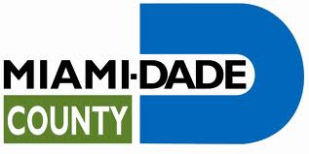

Miami-Dade County Traffic Control Center Internship Report
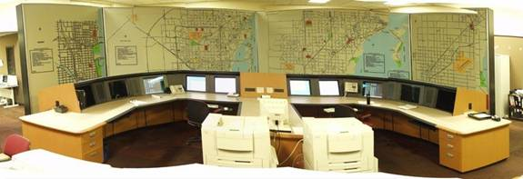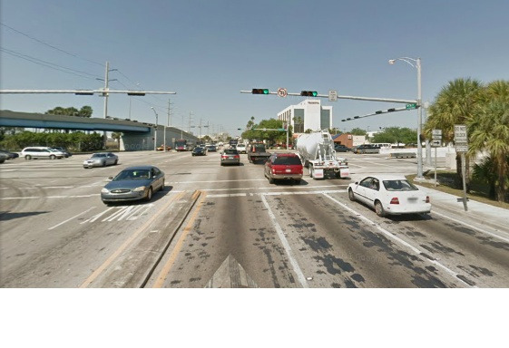
Nicholas Junqueira Hevia
Florida International University

July 2013

My name is Nicholas Hevia. I am a graduate student pursuing a master’s degree in Civil/Transportation Engineering at Florida International University (FIU). I obtained my Bachelor of Science in Civil Engineering in May 2012 from the University of Florida. Upon graduating I went back to my hometown Miami and a few months later decided it would be better to pursue an advanced degree in Civil Engineering. During my internship at the Miami-Dade County Traffic Control Center, I worked under the supervision of Hiram Hernandez, who is the Senior Professional Engineer and Manager within the county’s Traffic Operations Office.
Miami-Dade County uses an Advanced Traffic Management System (ATMS) to help manage its arterials. The county has over 2,800 signalized intersections. Operating and maintaining these signals is the responsibility of the Miami-Dade Public Works and Waste Management Department’s Traffic Signals and Signs Division. Approximately 70 Electrical Technicians, Systems Operators, Traffic Operations Engineers, and managers work full-time to ensure the signals are timed and operating optimally to keep traffic moving safely and efficiently. The County’s new ATMS is a state-of-the-art, distributed traffic signal monitor and control system and is the most important tool we have at our disposal here at the Traffic Control Center. With it we have the ability to optimize traffic signal operations at all locations and at any time of the day. The system also monitors the performance of the signals and automatically notifies appropriate staff when a traffic signal malfunctions, enabling staff to respond with maximum efficiency and effectiveness. ATMS reduces delays and improves arterial mobility within the County. It improves traffic flow by coordinating the signals on major county arterials to run as an integrated network system rather than individual entities, hence reducing congestions.
My role at the Miami-Dade County Traffic Control Center was to assist the Traffic Engineers with arterial management and in so doing I have learned a great deal about Traffic Operations, Signal Operation Plans (SOP), intersection plans, traffic signal operations and signal timing. I first started out learning the two main software programs used by the Traffic Engineers. The first and most crucial software used at the Control Center is the Kimely-Horn Integrated Transportation System (KITS). This software is extremely useful. With it you can view an event log report, view (in real-time) signal operations, verify if a detector or loop has malfunctioned and much more for any intersection in Miami-Dade. Using KITS I have been able to improve signal operation and timing from the comfort of my desk. Miami-Dade’s ATMS has been equipped with a wireless communication system. 30% of all intersections are connected wirelessly while the other 70% use digital based land line communication. Changes to any intersection can be made without having to go out to the field. The second most useful software here at the Traffic Control Center is the Advanced Traffic Management System (ATMS). Using this software, engineers can dispatch any issue with an intersection to the maintenance crew. For example, if a green bulb is out or a detector is not working properly, the engineer will use ATMS to dispatch the problem to the maintenance crew. The maintenance crew will then go out to the field to fix the problem in order of severity. ATMS also keeps a log of all changes and dispatches made to a particular intersection.

Under the supervision of the Traffic Engineers, I have made timing improvements to the intersections of NW 116th Way with Okeechobee Road (SR-27) and NW 36th Street with NW South River Drive. Traffic on SR-27 would back up on the eastbound through lanes (EBT). SR-27 is a major arterial and serves many businesses and large trucks. During the morning peak hours (7:00 a.m. to 9:00 a.m.) trucks that were making a left turn from the westbound left (WBL) direction would end up blocking the EBT lanes because 116th Way with SR-27 is extremely close to the intersection of 116th Way with NW South River Drive and while these trucks were turning left, 116th Way with South River Drive was red causing a backup to occur. The solution was to alter the timing for 116th Way with South River Drive by changing the signal offset using KITS so that when the WBL on SR-27 ended, 116th Way with NW South River Drive turned green allowing sufficient time for all the trucks to pass and clear through the intersection and would no longer block the EBT traffic on SR-27. NW 36th Street with South River Drive also shares proximity with NW 36th Street and Le June Road (SR-953). Just like SR-27 with 116th Way, the Traffic during peak afternoon hours on NW 36th Street is high. The WBT traffic on 36th with SR-953 would begin backing up all the way to the intersection of 36th Street with South River Drive when red. Instead of 36th St with SR-953 turning green first to allow the backup to clear the opposite would happen. 36th Street with South River Drive would turn green first but due to the heavy WBT backup on SR-953, the WBT traffic on 36th with South River Drive would have to wait at the light until SR-953 turned green and traffic cleared enough to start proceeding through the intersection. This issue was also corrected by modifying the signal offset at both intersections using KITS.
I also had the opportunity to fix a Maintenance of Traffic (MOT) issue at the intersection of US-1 with SW 17th Avenue. Construction in the area had closed off the Southbound through (SBT) traffic from 17th Ave with US-1. The Traffic Engineering Department (TED) located in Downtown Miami failed to contact us first and implemented a MOT that was not effective. The TED detoured traffic from 17th Ave by making a right onto US-1 following a left onto 22nd Avenue. The problem with this was that during morning peak hours, the Westbound left (WBL) on US-1 with 22nd Ave is skipped and due to the high traffic volumes during peak hours on US-1 the drivers would have a very difficult time attempting to make the permissive left turn that for the most part could only be done when the WBT and EBT cycles went into clearance. This caused heavy backups on the WBL banks that would stretch out into the left most lane on US-1 resulting in delays. What I came up with was a different MOT plan that directed the southbound traffic from 17th Ave to make a right onto 24th Terrace instead of US-1. From 24th Terrace, traffic would then make a left onto 22nd Ave. 5 seconds of green time was added to the SBT traffic on 22nd Ave to allow for the extra flow of southbound traffic to clear within the phase.
In addition, I also had the opportunity to dispatch the maintenance crew to NW 122nd Street with W 67th Place. I made an observation at that intersection and concluded that it was not operating the way it was designed to. Upon arriving at the control center I entered KITS and discovered that there was indeed a problem. The detectors were not functioning correctly and the loops were damaged. People wanting to make a left from 67th Place would have to wait there until the main phases on 122nd Street maxed out. There was also a Five-Section head that was not programmed correctly. Using ATMS I made a dispatch to the intersection and the maintenance team fixed the problem. Now vehicles waiting at the left turn bay at 67th Place are detected and when the WBL arrow on 122nd Street comes up, the Five-Section head for the Northbound right (NBR) on 67th Place now brings up the right turn arrow as it was supposed to be programmed to do.
My internship with the Miami-Dade County Traffic Control Center has been an incredible experience. I have had the opportunity to learn a great deal about traffic operations and ATMS. I was able to apply my engineering judgment into real-life situations and enhance my technical background. Working for the Miami-Dade County Traffic Control Center was motivating and made me become more enthusiastic with transportation engineering and the outlook for this career looks very promising. As technology advances and population rises, the demand for transportation engineers will no doubt be on the rise. Learning about ATMS and traffic operations helped me look into the future of transportation engineering and shifted my career interest into traffic operations. I am very thankful for the experience and hope to become a Traffic Engineer here one day.

